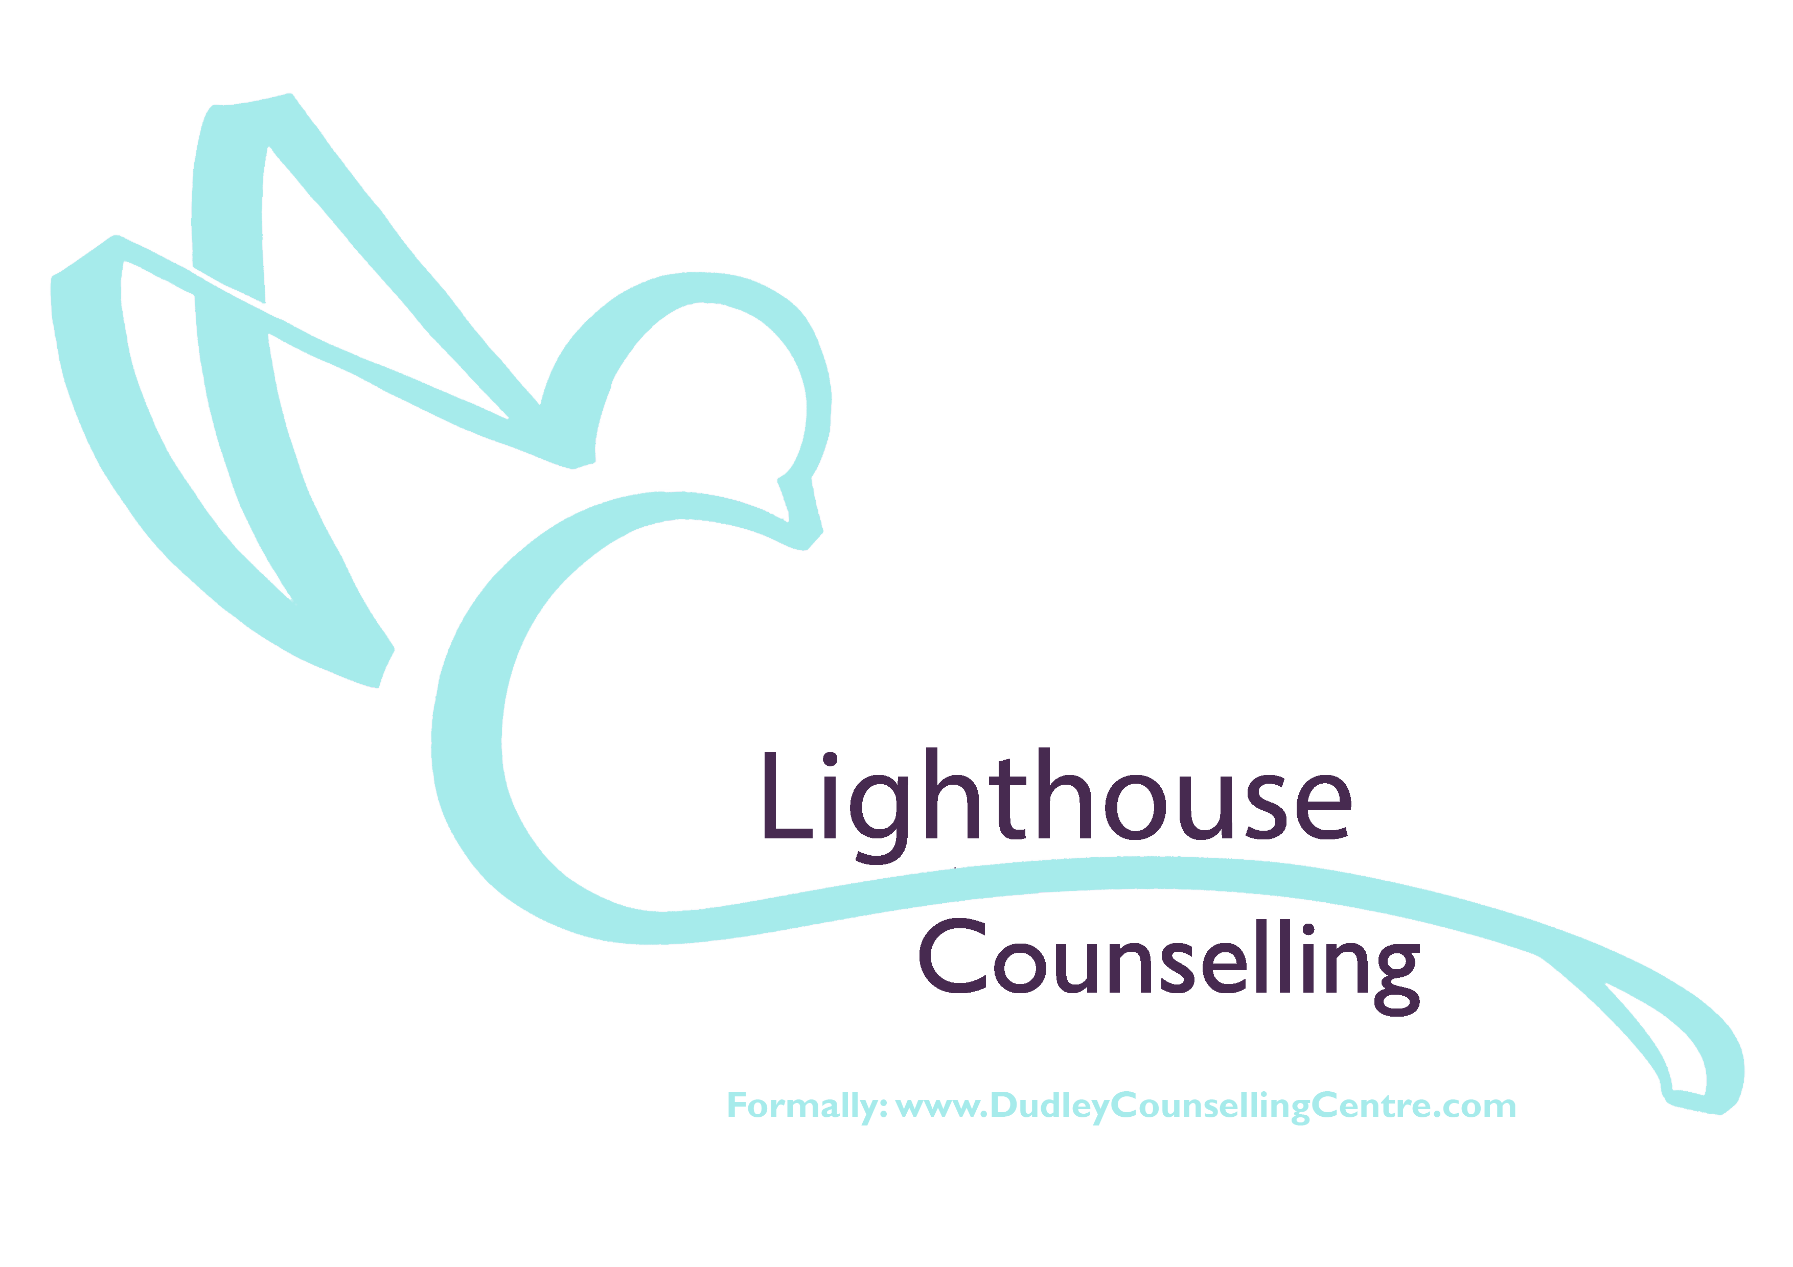
Relationship / Couples Counselling Referral

Please complete all fields in the following form, you can email or post back to Lighthouse Counselling.

Please include information of both parties

Title | Title
Forename | Forename
Surname | Surname
Date of Birth | Date of Birth
Address | Address (if different)
Postcode | Postcode
Main Contact Numbers | Main Contact Numbers
Can we leave messages?  Yes No | Can we leave messages?  Yes No
Your Email | Your Email
Employment Status | Employment Status
Gender | Gender
Ethnicity | Ethnicity
Religion (if none, enter 'none') | Religion (if none, enter 'none')
Relationship Status | Relationship Status
Length of relationship
Any dependent(s) of this relationship / previous relationship:

Do you have a disability we should take into account when allocating appointment premises? (required) Yes / No | Do you have a disability we should take into account when allocating appointment premises? (required) Yes / No
YOUR CURRENT DIFFICULTIES
Please give any further details that you feel would help us understand your current problem?

What would you like to achieve within the Relationship / Couples counselling sessions?

So that we can complete an initial assessment of both party’s needs, can you advise of the best day or time for us to contact each individual?

Days & Timings of when both parties could attend counselling appointments together:

Both parties must provide consent. Please sign below to confirm that you give consent for the above information to be used in assessment.

Sign…………………………………..….. Date …………………………

Sign…………………………………..….. Date …………………………
Your completed form will be assessed by a qualified counsellor, who will contact regarding the next step in our process of counselling provision.

Should you have any questions please feel free to get in touch either by email; admin@lighthousecounselling.org or telephone 01384 239222.

You can return the completed form via email to admin@lighthousecounselling.org

Post or deliver by hand to;
The Lighthouse Centre
Lighthouse Counselling
Salop Street,
Dudley, DY1 3AT

